|  |  |
| --- | --- |
| **Chapter 2** | **Digit sums, casting out 9’s and 9’ check method** |
|  |  |



The word digit means a single figure number: The numbers 1, 2, 3, 4, 5, 6, 7, 8, 9, 0 are all digits. Big numbers can be reduced to single digit by adding the constituents.

# Digit Sums

A digit sum is the sum of all the digits of a number and is found by adding all of the digits of a number The digit sum of 35 is 3 + 5 = 8

The digit sum of 142 is 1 + 4 + 2 = 7

***Note :*** If the sum of the digits is greater than 9, then sum the digits of the result again until the result is less than 10.

greater than 9, so need to add again

The digit of 57 is 5 + 7 = 12  1 + 2 = 3 Hence the digit sum of 57 is 3.

The digit sum of 687 is 6 + 8 + 7 = 21  2 + 4 = 3 Hence the digit sum of 687 is 3.

* Keep findig the digit sum of the result + unitl it's less then 10
* 0 and 9 are requivalent

Look and undevstand some more example :

To find the digit sum of 18, for the example we just add 1 and 8, i.e.1 + 8 =9 so the digit sum of 18 is 9. And the digit sum of 234 is 9 because 2 + 3+ 4 = 9

Following table shows how to get the digit sum of the following members

|  |  |
| --- | --- |
| 15 | 6 |
| 12 | 3 |
| 42 | 6 |
| 17 | 8 |
| 21 | 3 |
| 45 | 9 |
| 300 | 3 |
| 1412 | 8 |
| 23 | 5 |
| 22 | 4 |

Sometimes two steps are needed to find a digit sum.

So for the digit sum of 29 we add 2 + 9 = 11 but since 11 is a 2-digit number we add again 1+1=1 So for the digit sum of 29 we can write

29 = 2 + 9 = 11 = 1 + 1 = 1

**1**

Similarity for 49 = 4 + 9 = 13 = 1 + 3 = 4 So the digit sum of 49 is 4.

|  |  |  |
| --- | --- | --- |
| **Number 14** | **Digit sum 1 + 4 = 5** | **Single digit 5** |
| 19 | 1 + 9 = 10 | 1 |
| 39 | 3+ 9 = 12 | 3 |
| 58 | 5 + 8 = 13 | 4 |
| 407 | 4 + 0 + 7 = 11 | 2 |

# CASTING OUT NINE

Adding 9 to a number does not affect its digit sum So 5, 59, 95, 959 all have digit sum of 5.

For example to find out the digit sum of 4939 we can cast out nines and just add up the 3 and 4 so digit sum is 7 or using the longer method we add all digit 4 + 9 + 3+ 9 =25 = 2 + 5=7

There is another way of casting out the nines from number when you are finding its digit sum. Casting out of 9’s and digit totalling 9 comes under the Sutra when the samuccaya is the same it is

zero.

So in 465 as 4 and 5 total nine, they are cast out and the digit sum is 6: when the total is the same

(as 9) it is zero (can be cast out) cancelling a common factor in a fraction is another example.

# Nine Point Circle

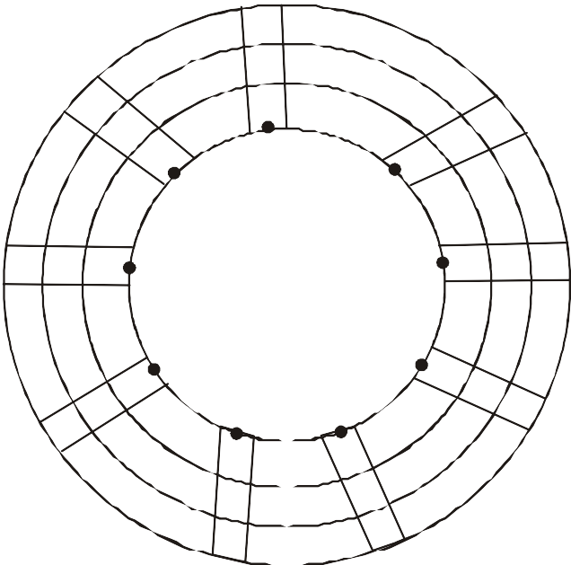

26

27

18

9

17

19

8

1

10

25 16

7

2 11 20

6

3

24

15

12

21

5

14

23

4

13

22

|  |  |
| --- | --- |
| **Number** | **Digit sum** |
| 1326 | 3 |
| 25271 | 8 |
| 9643 | 4 |
| 23674 | 4 |
| 128541 | 3 |
| 1275 | 6 |
| 6317892 | 9 or 0 |

Number at each point on the circle have the same digit sum.

By casting out 9's, finding a digit sum can be done more quickly and mentally.

**2**

# Check Method

Digit sum can be used to check that the answers are correct.

**Example:** Find 23 + 21 and check the answer using the digit sums

23 = digit sum of 23 is 2 + 3 = 5

+21 = digit sum of 21 is 2 + 1 = 3

44 = digit sum of 44 is 4 + 4 = 8

If the sum has been done correctly, the digit sum of the answer should also be 8 Digit sum of 44=8 so according to this check the answer is probably correct.

There are four steps to use digit sum to check the answers:

* 1. Do the sum.
  2. Write down the digit sums of the numbers being added.
  3. Add the digit sums.
  4. Check whether the two answers are same in digit sums. Add 278 and 119 and check the answer

278

+119

397

* + 1. We get 397 for the answer
    2. We find the digit sum of 278 and 119 which are, 8 and 2 respectively
    3. Adding 8 and 2 gives 10, digits sum of 10=1+0=1
    4. Digit sum of 397 is

3 + 9 + 7 = 19 =1 + 9 = 10 = 1 + 0 = 1

Which confirm the answer?

# CAUTION!

Check the following sum:

279 9

121 4

490 4

Here an estimation can help you to find the result more accurate if by mistage you write 400 in place of 490 then it will show the result is correct.

The check is 9 + 4 = 13 = 4 which is same as the digit sum of the answer which confirms the answer.

However if we check the addition of the original number we will find that it is incorrect! This shows that the digit sum does not always find errors. It usually works but not always. We will be looking at another checking device i.e. 11 - check method.

***Note :*** The difference of 9 and its multiples in the answer make errors. So, keep in mind a rough estimation.

**3**

# Practice Problems

**Digit sum Puzzles**

1. **The digit sums of a two digit number is 8 and figures are the same, what is the number?**
2. **The digit sum of a two digit number is 9 and the first figure is twice the second, what is it?**
3. **Give three two digit numbers that have a digit sum of 3.**
4. **A two digit number has a digit sum of 5 and the figures are the same. What is the number?**
5. **Use casting out 9’s to find the digit sums of the numbers below.**

|  |  |
| --- | --- |
| Number |  |
| 465 |  |
| 274 |  |
| 3456 |  |
| 7819 |  |
| 86753 |  |
| 4017 |  |
| 59 |  |

1. **Add the following and check your answer using digit sum check**

(1) 66 + 77 = (2) 57 + 34 =

(3) 94 + 89 = (4) 304 + 233 =

(5) 787 + 132 = (6) 389 + 414 =

(7) 5131 + 5432 = (8) 456 + 654 =

**4**